Docker-01 Tasks
Task 1: Launch an Ubuntu EC2 virtual machine
Step 1: Open EC2
- Sign in to the AWS Management Console.
- Select your required AWS Region.
  - Recommended: Mumbai ap-south-1
- Search for EC2.
- Open EC2 Dashboard.
- Click Launch instance.
Step 2: Name the instance
Enter:
Docker-Practice-Server
Step 3: Select Ubuntu AMI
Under Application and OS Images:
- Choose Ubuntu.
- Select:
Ubuntu Server 26.04 LTS (HVM), SSD Volume Type
- Architecture:
64-bit (x86)
Avoid ARM architecture because some Docker images or plugins may have compatibility differences.
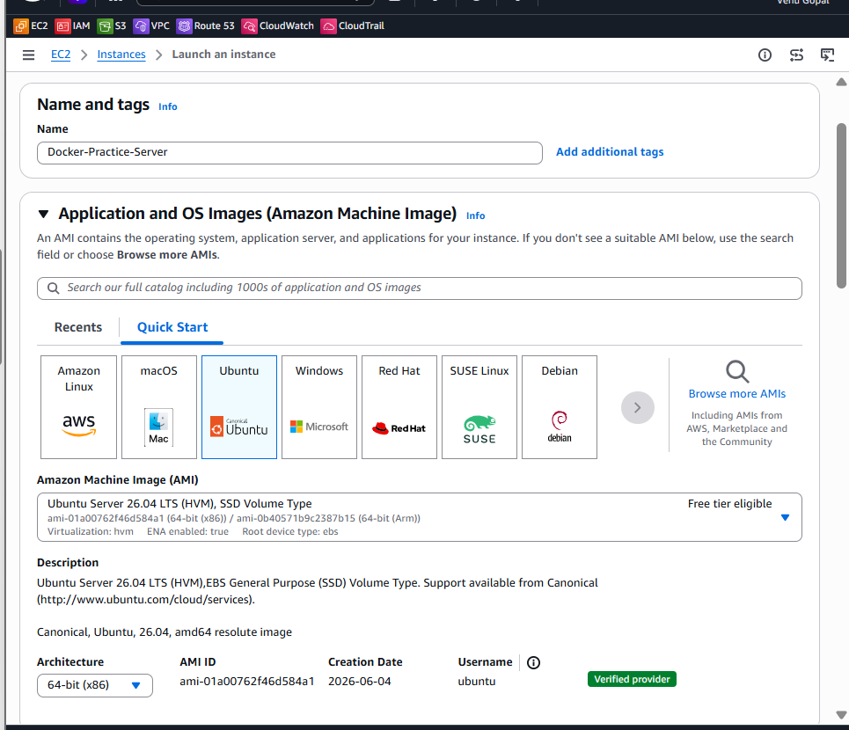
Step 4: Choose the instance type
Select:
t3.small
Configuration:
2 vCPU
4 GiB RAM
This is recommended because Jenkins and SonarQube require more memory.
If this assignment is only for pulling and inspecting SonarQube—not running it—you can use t3.small. For smoother practice, use t3.medium.
Step 5: Create or select a key pair
Under Key pair (login):
- Select an existing Ubuntu-compatible key pair, or
- Click Create new key pair.
If creating one:
Key pair name: docker-practice-key
Key pair type: RSA
Private key format: .pem
Click Create key pair and keep the downloaded .pem file safely.
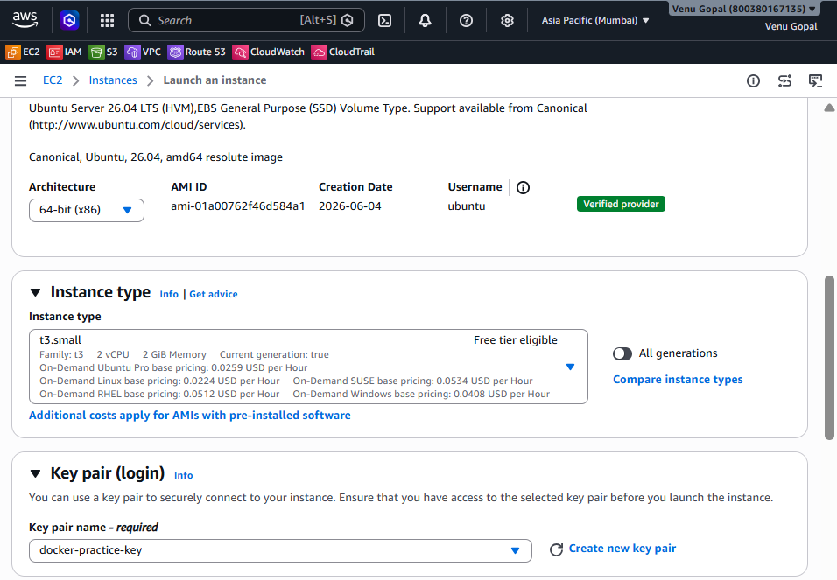
Step 6: Configure networking
Click Edit under Network settings.
Use:
VPC: Default VPC
Subnet: Any public subnet
Auto-assign public IP: Enable
Create a security group:
Security group name: Docker-Practice-SG
Description: Security group for Docker practice
Add these inbound rules:
Type | Port | Source | Purpose
SSH | 22 | My IP | Connect to Ubuntu
Custom TCP | 81 | My IP | Nginx container
Custom TCP | 8080 | My IP | Jenkins container
Custom TCP | 9000 | My IP | SonarQube, if required
For a classroom demo, you may temporarily use 0.0.0.0/0 for ports 81, 8080, and 9000. Do not open SSH port 22 to everyone.
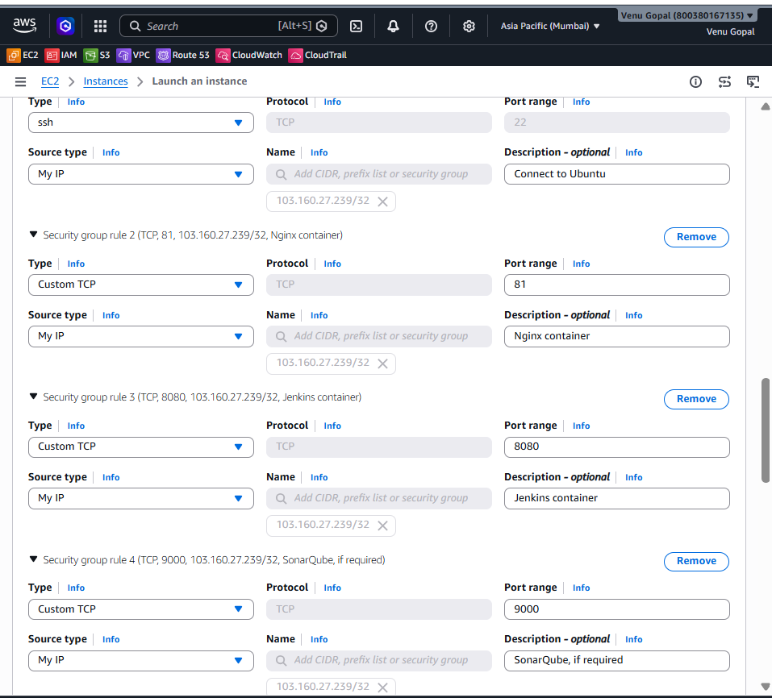
Step 7: Configure storage
Set:
20 GiB
gp3
Delete on termination: Yes
Docker images consume significant disk space, so 20 GiB is safer than the default 8 GiB.
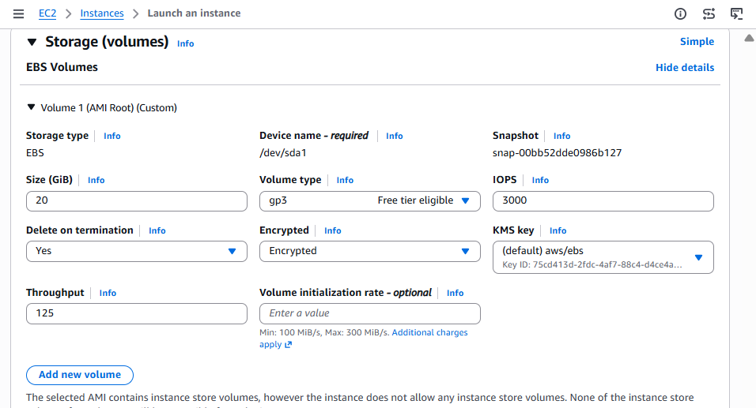
Step 8: Launch the instance
- Review the configuration.
- Click Launch instance.
- Click View all instances.
- Wait until:
Instance state: Running
Status checks: 2/2 checks passed
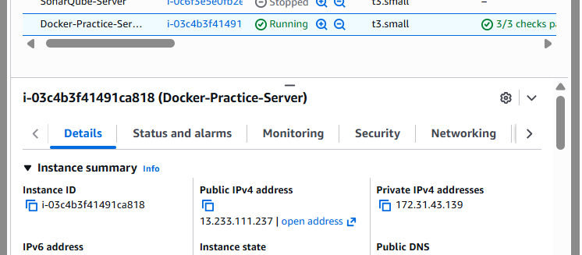
Step 9: Connect from Windows Git Bash
Select the instance and copy its Public IPv4 address.
Move to the directory containing your .pem file:
cd /path/to/key-folder
Set key permissions:
chmod 400 docker-practice-key.pem
Connect:
ssh -i docker-practice-key.pem ubuntu@PUBLIC_IP
Replace PUBLIC_IP with the instance’s actual public IP.
After connecting, verify the operating system:
hostname
cat /etc/os-release
You should see Ubuntu 24.04 information.
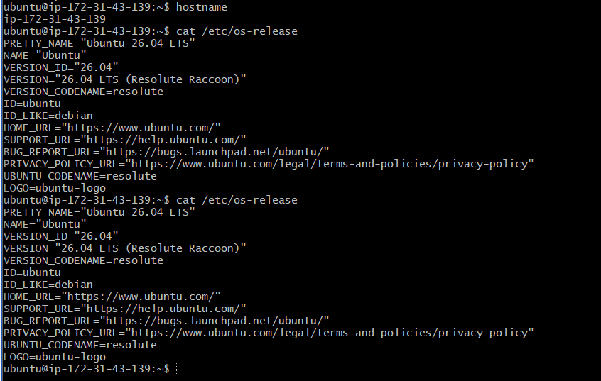
Task 2: Install Docker on Ubuntu
Run the following commands inside your EC2 terminal.
Step 1: Update Ubuntu packages
sudo apt update
Wait until it finishes successfully.
Step 2: Install required packages
sudo apt install -y ca-certificates curl
Step 3: Add Docker’s official GPG key
sudo install -m 0755 -d /etc/apt/keyrings
sudo curl -fsSL https://download.docker.com/linux/ubuntu/gpg \
-o /etc/apt/keyrings/docker.asc
sudo chmod a+r /etc/apt/keyrings/docker.asc
Step 4: Add Docker’s official repository
Copy and run this complete command:
echo "Types: deb
URIs: https://download.docker.com/linux/ubuntu
Suites: $(. /etc/os-release && echo "${UBUNTU_CODENAME:-$VERSION_CODENAME}")
Components: stable
Architectures: $(dpkg --print-architecture)
Signed-By: /etc/apt/keyrings/docker.asc" | \
sudo tee /etc/apt/sources.list.d/docker.sources > /dev/null
Update the package list again:
sudo apt update
Step 5: Install Docker Engine
sudo apt install -y docker-ce docker-ce-cli containerd.io docker-buildx-plugin docker-compose-plugin
Step 6: Check the Docker service
sudo systemctl status docker --no-pager
Expected:
Active: active (running)
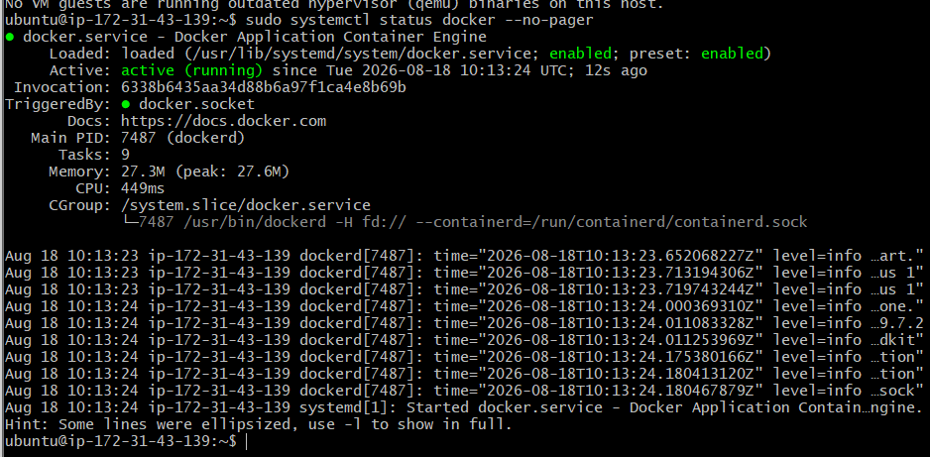
Step 7: Allow the Ubuntu user to run Docker
sudo usermod -aG docker ubuntu
Apply the new group membership immediately:
newgrp docker
Step 8: Verify Docker
docker --version
docker compose version
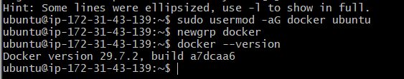
Run the test container:
docker run --rm hello-world
Expected message:
Hello from Docker!
Finally, check:
docker ps
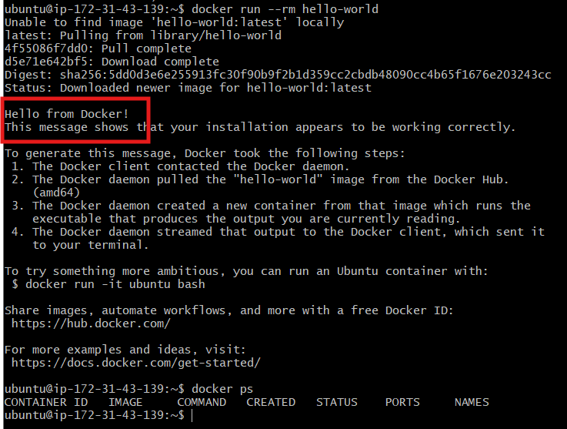
Task 3: Pull five Docker images
Pull each image individually so that we can verify every download.
1. Pull Nginx
docker pull nginx:latest
2. Pull Apache Tomcat
docker pull tomcat:latest
3. Pull Ubuntu
docker pull ubuntu:latest
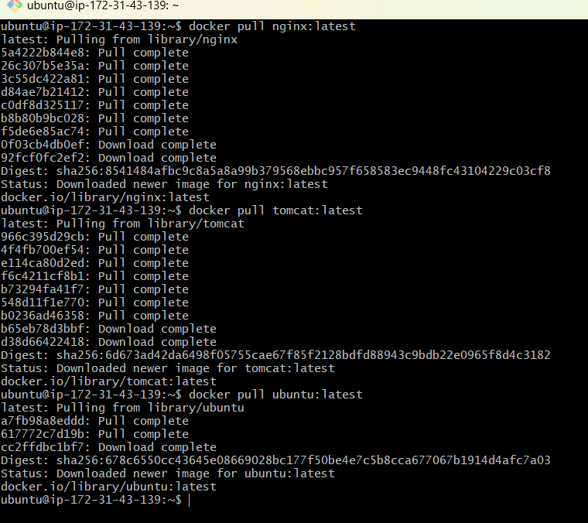
4. Pull Jenkins LTS
docker pull jenkins/jenkins:lts-jdk21
The official Jenkins image name is jenkins/jenkins, not simply jenkins.
5. Pull SonarQube Community Build
docker pull sonarqube:community
The Jenkins and SonarQube images are large, so downloading them can take several minutes.
Verify all five images
docker images
You should see:
nginx
tomcat
ubuntu
jenkins/jenkins
sonarqube
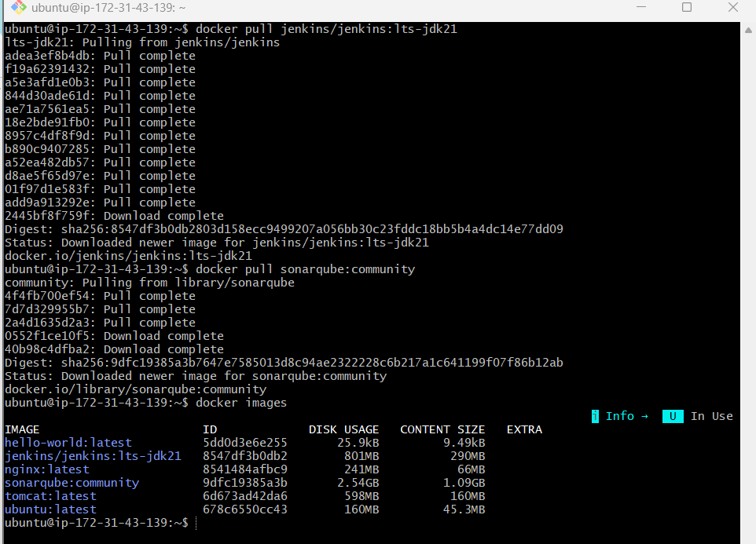
To display only the required images neatly:
docker images --format "table {{.Repository}}\t{{.Tag}}\t{{.ID}}\t{{.Size}}"
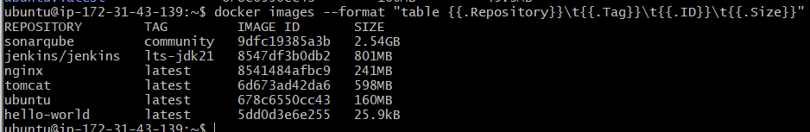
Task 4: Run Nginx container on port 81
Step 1: Start the Nginx container
docker run -d --name nginx-container -p 81:80 nginx:latest
Explanation:
-d Run in background
--name nginx-container Container name
-p 81:80 EC2 port 81 → container port 80
nginx:latest Image
Step 2: Verify the running container
docker ps
Expected port mapping:
0.0.0.0:81->80/tcp
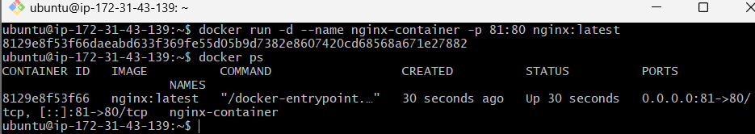
Step 3: Test from inside EC2
curl http://localhost:81
You should receive HTML containing:
Welcome to nginx!
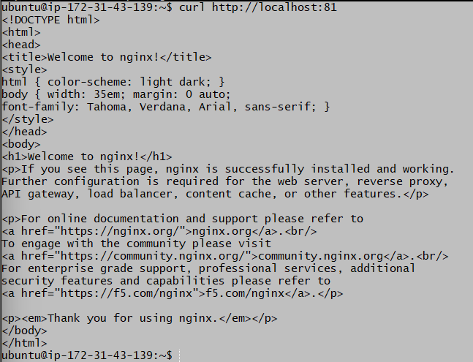
Step 4: Test from your browser
Copy the EC2 Public IPv4 address from the AWS console and open:
http://PUBLIC_IP:81
Example:
http://13.233.xx.xx:81
Do not use the private IP 172.31.43.139 from your computer.
You should see the Welcome to nginx! page.
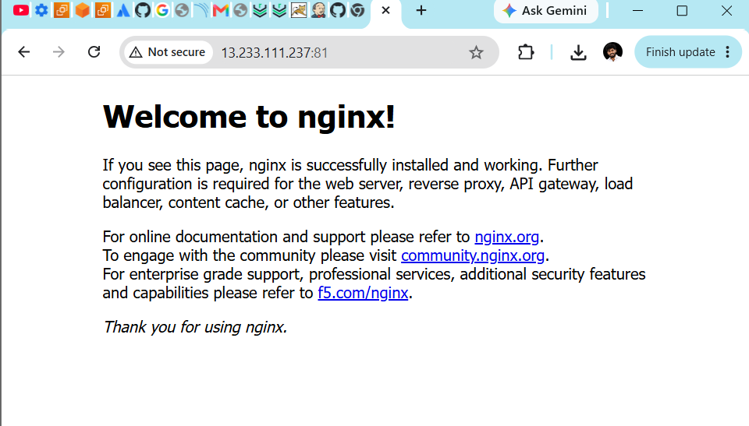

Task 5: Delete the Apache Tomcat image
First confirm the Tomcat image exists:
docker images tomcat
Check whether any container uses it:
docker ps -a --filter ancestor=tomcat:latest
If no container is displayed, delete the image:
docker rmi tomcat:latest
Expected output will resemble:
Untagged: tomcat:latest
Deleted: sha256:...
Verify that it has been removed:
docker images tomcat
The result should display only the headings with no Tomcat image.
Also confirm that Nginx is still running:
docker ps
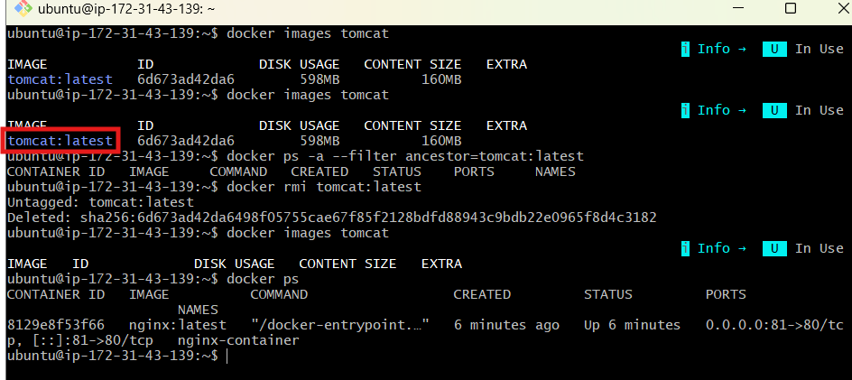

Task 6: Inspect Jenkins and SonarQube images
docker inspect displays detailed JSON metadata such as environment variables, ports, user, entry point, command, architecture and image layers.
Step 1: Inspect the Jenkins image
docker inspect jenkins/jenkins:lts-jdk21
The output will be long. Display the important information separately:
docker image inspect jenkins/jenkins:lts-jdk21 \
--format 'User={{.Config.User}} Ports={{json .Config.ExposedPorts}} Entrypoint={{json .Config.Entrypoint}}'
Expected details should include:
User=jenkins
Port=8080/tcp
Port=50000/tcp
- 8080: Jenkins web interface
- 50000: Jenkins inbound-agent communication
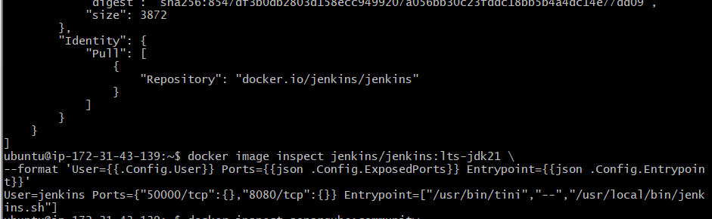
Step 2: Inspect the SonarQube image
docker inspect sonarqube:community
Display the important information:
docker image inspect sonarqube:community \
--format 'User={{.Config.User}} Ports={{json .Config.ExposedPorts}} Entrypoint={{json .Config.Entrypoint}}'
Expected details should include:
User=sonarqube
Port=9000/tcp
- 9000: SonarQube web interface
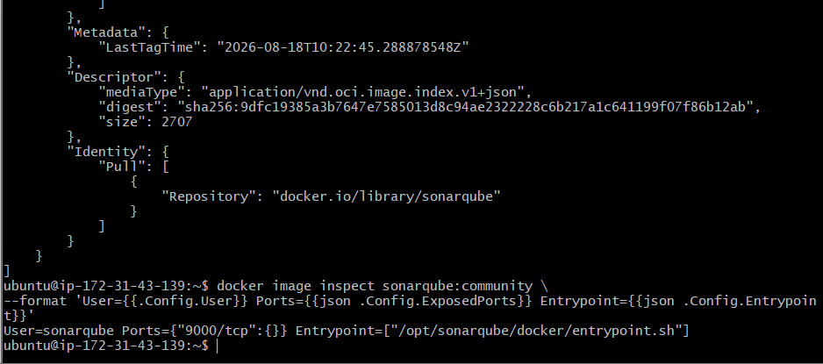
Step 3: Check architecture and operating system
docker image inspect jenkins/jenkins:lts-jdk21 \
--format 'Jenkins: OS={{.Os}}, Architecture={{.Architecture}}'
docker image inspect sonarqube:community \
--format 'SonarQube: OS={{.Os}}, Architecture={{.Architecture}}'
Expected:
OS=linux
Architecture=amd64
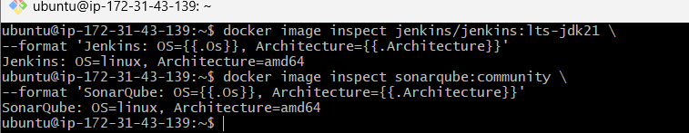
Step 4: Check image history/layers
docker history jenkins/jenkins:lts-jdk21
docker history sonarqube:community
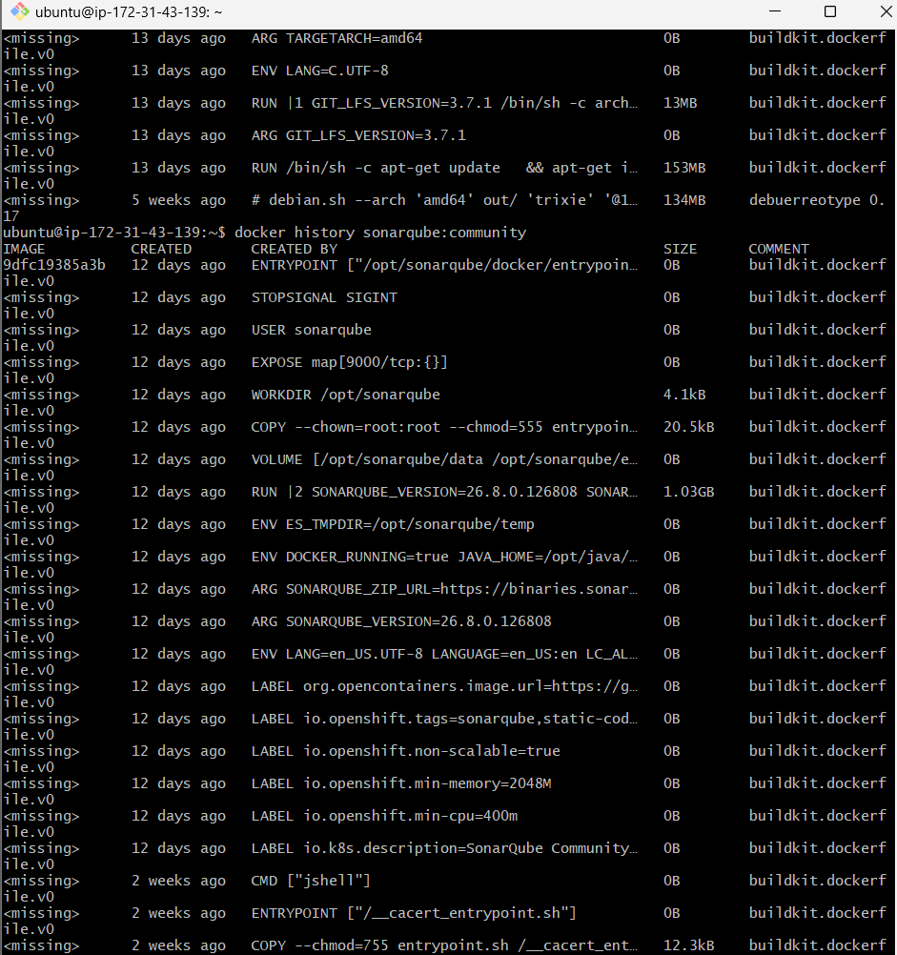
Task 7: Run Jenkins and execute a sample job
Step 1: Create persistent Jenkins storage
docker volume create jenkins-home
Verify:
docker volume ls
Step 2: Run the Jenkins container
docker run -d \
--name jenkins-container \
--restart unless-stopped \
-p 8080:8080 \
-p 50000:50000 \
-v jenkins-home:/var/jenkins_home \
jenkins/jenkins:lts-jdk21
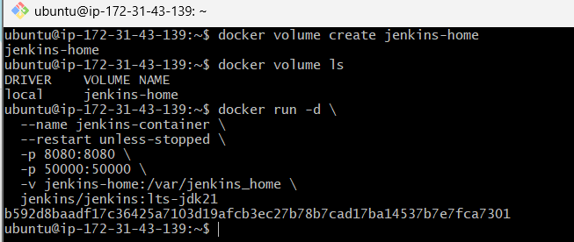
Step 3: Check the container
docker ps
Expected mappings:
0.0.0.0:8080->8080/tcp
0.0.0.0:50000->50000/tcp
Check startup logs:
docker logs -f jenkins-container
Wait until you see:
Jenkins is fully up and running
Press Ctrl+C to exit the log view. This will not stop Jenkins.
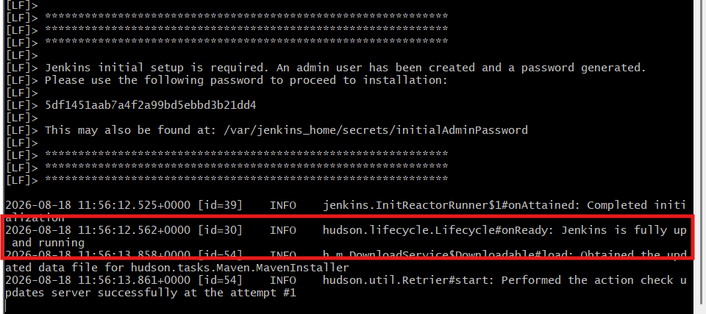
Step 4: Get the initial administrator password
docker exec jenkins-container \
cat /var/jenkins_home/secrets/initialAdminPassword
Copy the displayed password.( 5df1451aab7a4f2a99bd5ebbd3b21dd4)
Step 5: Open Jenkins
From the EC2 console, copy the instance’s Public IPv4 address and open:
http://PUBLIC_IP:8080
If it does not open, confirm that security-group port 8080 allows your current public IP.
Step 6: Complete Jenkins setup
- Paste the initial administrator password.
- Click Continue.
- Select Install suggested plugins.
- Wait for plugin installation.
- Create the administrator:
Username: jenkinsadmin
Password: Create a strong password
Full name: Jenkins Admin
- Keep the default Jenkins URL.
- Click Save and Finish.
- Click Start using Jenkins.
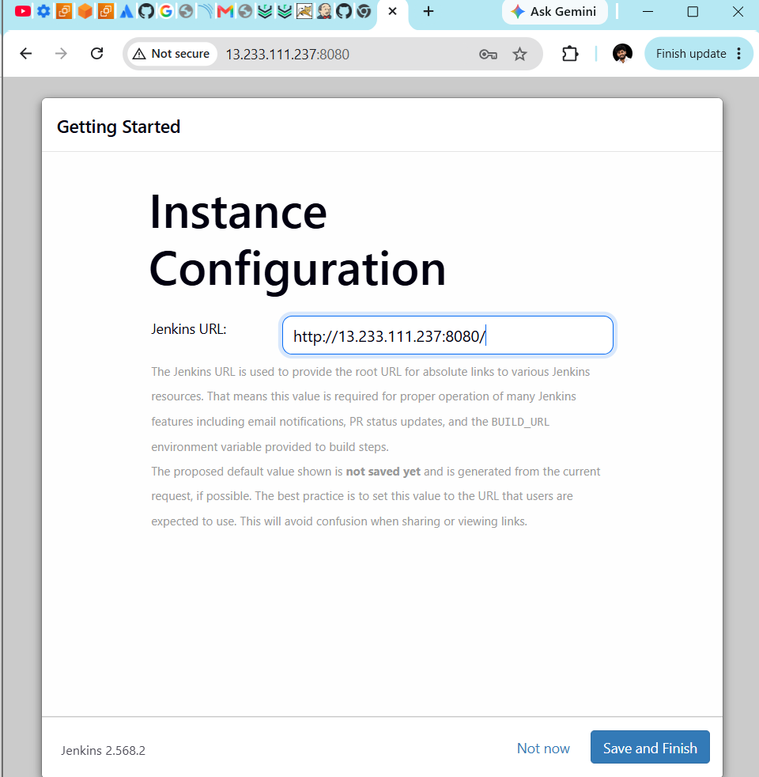
Create a sample Jenkins job
Step 7: Create the job
- From Dashboard, click New Item.
- Enter:
Docker-Sample-Job
- Select Freestyle project.
- Click OK.
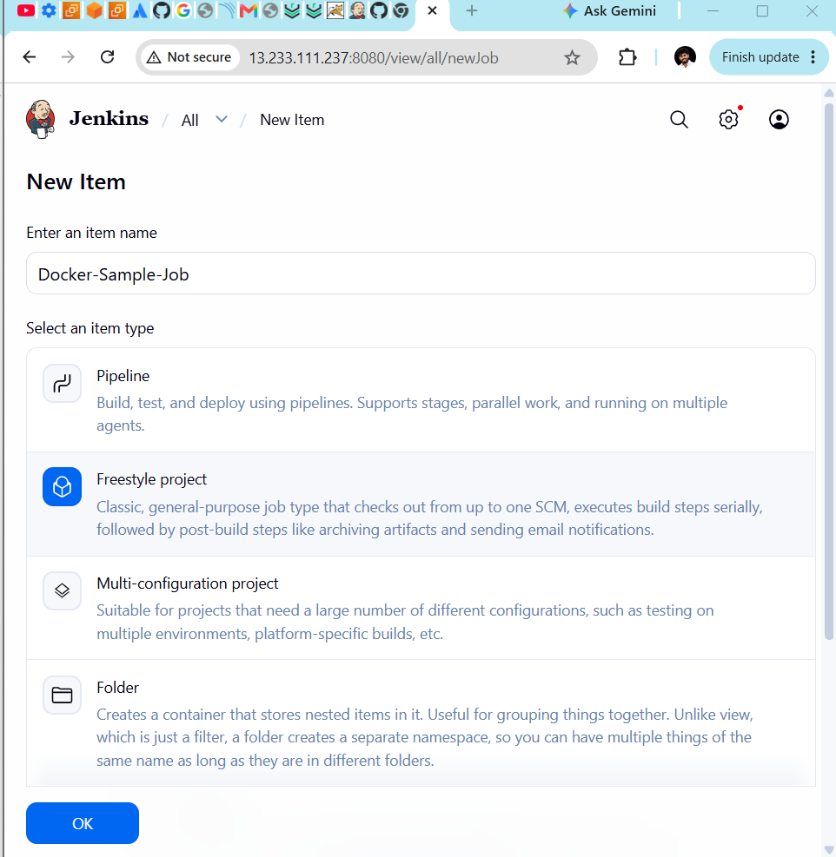
Step 8: Add a build step
- Scroll to Build Steps.
- Click Add build step.
- Select Execute shell.
- Enter:
echo "Hello from Jenkins running inside Docker!"
echo "Job name: $JOB_NAME"
echo "Build number: $BUILD_NUMBER"
echo "Workspace: $WORKSPACE"
date
uname -a
- Click Save.
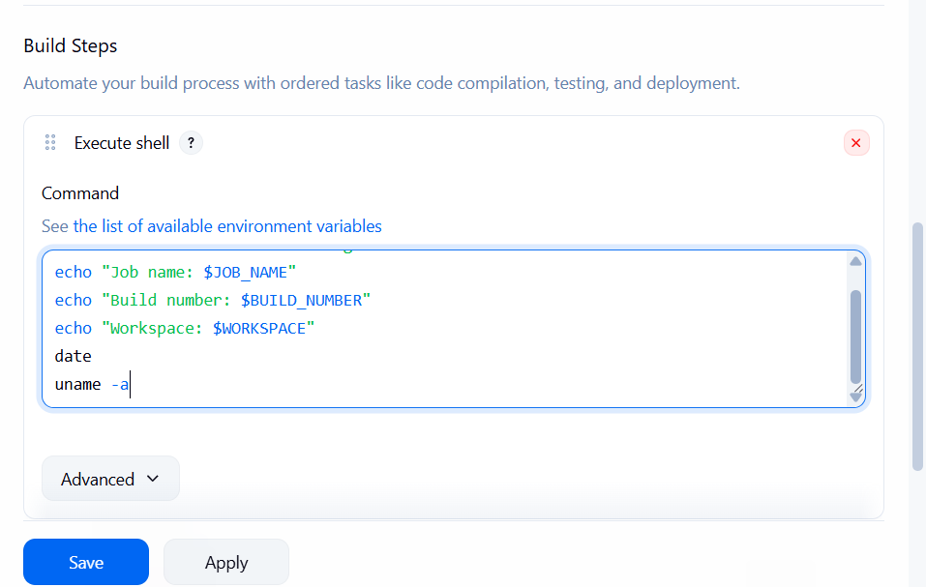
Step 9: Run the job
- Click Build Now.
- Under Build History, click build #1.
- Click Console Output.
Expected:
Hello from Jenkins running inside Docker!
Job name: Docker-Sample-Job
Build number: 1
Finished: SUCCESS
